Build a Node.js web application using DocumentDB

This Node.js tutorial shows you how to use the Azure DocumentDB service to store and access data from a Node.js Express application hosted on Azure Websites.

you'll learn the answers to the following questions:

* How do I work with DocumentDB using the documentdb npm module?
* How do I deploy the web application to Azure Websites?

By following this database tutorial, you will build a simple web-based task-management application that allows creating, retrieving and completing of tasks. The tasks will be stored as JSON documents in Azure DocumentDB.

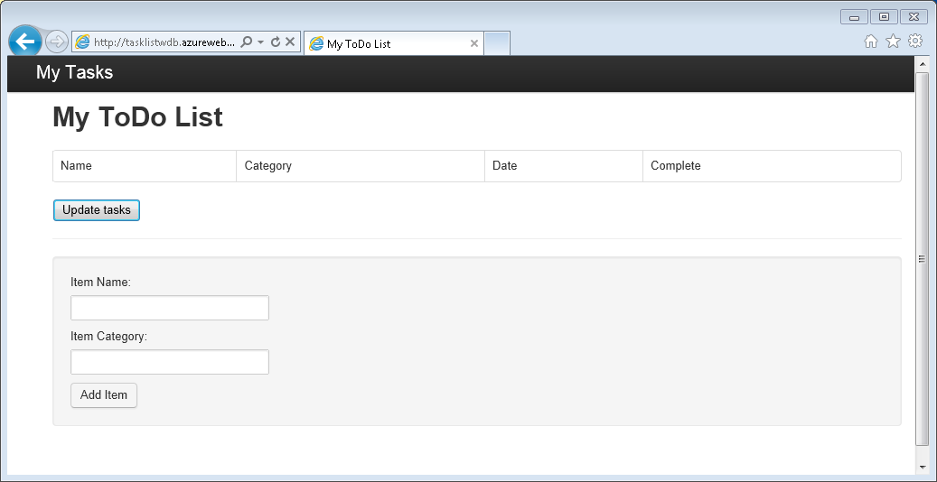

## **Prerequisites**

##### **Tip:**

This Node.js tutorial assumes that you have some prior experience using Node.js and Azure Websites.

Before following the instructions in this article, you should ensure that you have the following:

* An active Azure account. If you don't have an account, you can create a free trial account in just a couple of minutes. For details, see [Azure Free Trial](https://azure.microsoft.com/pricing/free-trial/).
* [Node.js](http://nodejs.org/) version v0.10.29 or higher.
* [Express generator](http://www.expressjs.com/starter/generator.html) (you can install this via npm install express-generator -g )
* [Git](http://git-scm.com/).

## **Step 1: Create a DocumentDB database account**

Let's start by creating a DocumentDB account. If you already have an account, you can skip to [Step 2: Create a new Node.js application](https://azure.microsoft.com/en-in/documentation/articles/documentdb-nodejs-application/#_Toc395783178).

1. Sign in to the [Azure portal](https://portal.azure.com/).
2. In the Jumpbar, click **New**, click **Data + Storage**, and then click **DocumentDB (NoSQL)**.
3. In the **New account** blade, specify the desired configuration for the DocumentDB account.
   * In the **ID** box, enter a name to identify the DocumentDB account. When the **ID** is validated, a green check mark appears in the **ID** box. The **ID** value becomes the host name within the URI. The **ID** may contain only lowercase letters, numbers, and the '-' character, and must be between 3 and 50 characters. Note that documents.azure.com is appended to the endpoint name you choose, the result of which becomes your DocumentDB account endpoint.
   * In the **NoSQL API** box, select **DocumentDB**.
   * For **Subscription**, select the Azure subscription that you want to use for the DocumentDB account. If your account has only one subscription, that account is selected by default.
   * In **Resource Group**, select or create a resource group for your DocumentDB account. By default, a new resource group is created. For more information, see [Using the Azure portal to manage your Azure resources](https://azure.microsoft.com/en-in/documentation/articles/resource-group-portal/).
   * Use **Location** to specify the geographic location in which to host your DocumentDB account.
4. Once the new DocumentDB account options are configured, click **Create**. To check the status of the deployment, check the Notifications hub.
5. After the DocumentDB account is created, it is ready for use with the default settings. The default consistency of the DocumentDB account is set to **Session**. You can adjust the default consistency by clicking **Default Consistency** in the resource menu. To learn more about the consistency levels offered by DocumentDB, see [Consistency levels in DocumentDB](https://azure.microsoft.com/en-in/documentation/articles/documentdb-consistency-levels/).

Now navigate to the DocumentDB account blade, and click **Keys**, as we will use these values in the web application we create next.

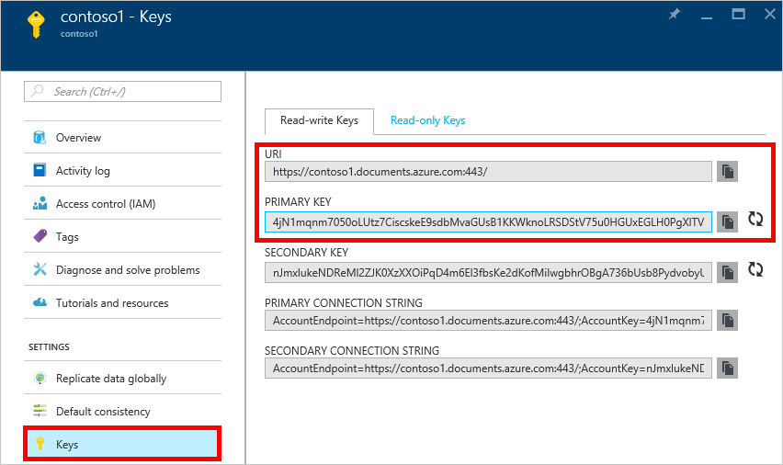

## **Step 2: Learn to create a new Node.js application**

Now let's learn to create a basic Hello World Node.js project using the [Express](http://expressjs.com/) framework.

1. Open your favorite terminal.
2. Install the express generator

Copy

npm install express-generator -g

1. Use the express generator to generate a new application called **todo**.

Copy

express todo

1. Open your new **todo** directory and install dependencies.

Copy

cd todo && npm install

1. Run your new application.

Copy

SET DEBUG=todo:* & npm start

1. You can you view your new application by navigating your browser to [http://localhost:3000](http://localhost:3000/).

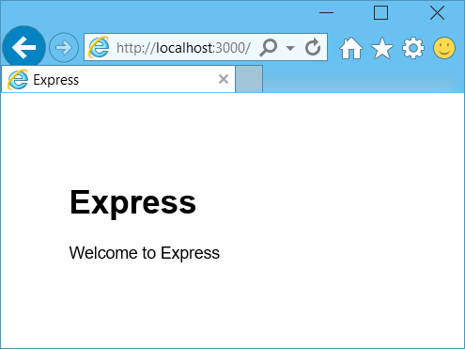

## **Step 3: Install additional modules**

The **package.json** file is one of the files created in the root of the project. This file contains a list of additional modules that are required for your Node.js application. Later, when you deploy this application to an Azure Websites, this file is used to determine which modules need to be installed on Azure to support your application. We still need to install two more packages for this tutorial.

1. Back in the terminal, install the **async** module via npm.

Copy

npm install async --save

1. Install the **documentdb** module via npm. This is the module where all the DocumentDB magic happens.

Copy

npm install documentdb --save

1. A quick check of the **package.json** file of the application should show the additional modules. This file will tell Azure which packages to download and install when running your application. It should resemble the example below.

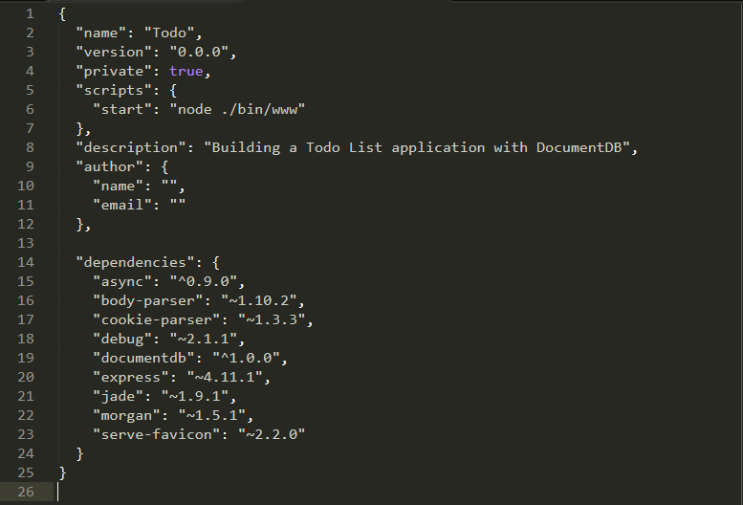

This tells Node (and Azure later) that your application depends on these additional modules.

## **Step 4: Using the DocumentDB service in a node application**

That takes care of all the initial setup and configuration, now let’s get down to why we’re here, and that’s to write some code using Azure DocumentDB.

### **Create the model**

1. In the project directory, create a new directory named **models**.
2. In the **models** directory, create a new file named **taskDao.js**. This file will contain the model for the tasks created by our application.
3. In the same **models** directory, create another new file named **docdbUtils.js**. This file will contain some useful, reusable, code that we will use throughout our application.
4. Copy the following code in to **docdbUtils.js**

Copy

var DocumentDBClient = require('documentdb').DocumentClient;

var DocDBUtils = {

getOrCreateDatabase: function (client, databaseId, callback) {

var querySpec = {

query: 'SELECT * FROM root r WHERE r.id= @id',

parameters: [{

name: '@id',

value: databaseId

}]

};

client.queryDatabases(querySpec).toArray(function (err, results) {

if (err) {

callback(err);

} else {

if (results.length === 0) {

var databaseSpec = {

id: databaseId

};

client.createDatabase(databaseSpec, function (err, created) {

callback(null, created);

});

} else {

callback(null, results[0]);

}

}

});

},

getOrCreateCollection: function (client, databaseLink, collectionId, callback) {

var querySpec = {

query: 'SELECT * FROM root r WHERE r.id=@id',

parameters: [{

name: '@id',

value: collectionId

}]

};

client.queryCollections(databaseLink, querySpec).toArray(function (err, results) {

if (err) {

callback(err);

} else {

if (results.length === 0) {

var collectionSpec = {

id: collectionId

};

client.createCollection(databaseLink, collectionSpec, function (err, created) {

callback(null, created);

});

} else {

callback(null, results[0]);

}

}

});

}

};

module.exports = DocDBUtils;

##### **Tip:**

createCollection takes an optional requestOptions parameter that can be used to specify the Offer Type for the Collection. If no requestOptions.offerType value is supplied then the Collection will be created using the default Offer Type.

For more information on DocumentDB Offer Types please refer to [Performance levels in DocumentDB](https://azure.microsoft.com/en-in/documentation/articles/documentdb-performance-levels/)

1. Save and close the **docdbUtils.js** file.
2. At the beginning of the **taskDao.js** file, add the following code to reference the**DocumentDBClient** and the **docdbUtils.js** we created above:

Copy

var DocumentDBClient = require('documentdb').DocumentClient;

var docdbUtils = require('./docdbUtils');

1. Next, you will add code to define and export the Task object. This is responsible for initializing our Task object and setting up the Database and Document Collection we will use.

Copy

function TaskDao(documentDBClient, databaseId, collectionId) {

this.client = documentDBClient;

this.databaseId = databaseId;

this.collectionId = collectionId;

this.database = null;

this.collection = null;

}

module.exports = TaskDao;

1. Next, add the following code to define additional methods on the Task object, which allow interactions with data stored in DocumentDB.

Copy

TaskDao.prototype = {

init: function (callback) {

var self = this;

docdbUtils.getOrCreateDatabase(self.client, self.databaseId, function (err, db) {

if (err) {

callback(err);

} else {

self.database = db;

docdbUtils.getOrCreateCollection(self.client, self.database._self, self.collectionId, function (err, coll) {

if (err) {

callback(err);

} else {

self.collection = coll;

}

});

}

});

},

find: function (querySpec, callback) {

var self = this;

self.client.queryDocuments(self.collection._self, querySpec).toArray(function (err, results) {

if (err) {

callback(err);

} else {

callback(null, results);

}

});

},

addItem: function (item, callback) {

var self = this;

item.date = Date.now();

item.completed = false;

self.client.createDocument(self.collection._self, item, function (err, doc) {

if (err) {

callback(err);

} else {

callback(null, doc);

}

});

},

updateItem: function (itemId, callback) {

var self = this;

self.getItem(itemId, function (err, doc) {

if (err) {

callback(err);

} else {

doc.completed = true;

self.client.replaceDocument(doc._self, doc, function (err, replaced) {

if (err) {

callback(err);

} else {

callback(null, replaced);

}

});

}

});

},

getItem: function (itemId, callback) {

var self = this;

var querySpec = {

query: 'SELECT * FROM root r WHERE r.id = @id',

parameters: [{

name: '@id',

value: itemId

}]

};

self.client.queryDocuments(self.collection._self, querySpec).toArray(function (err, results) {

if (err) {

callback(err);

} else {

callback(null, results[0]);

}

});

}

};

1. Save and close the **taskDao.js** file.

### **Create the controller**

1. In the **routes** directory of your project, create a new file named **tasklist.js**.
2. Add the following code to **tasklist.js**. This loads the DocumentDBClient and async modules, which are used by **tasklist.js**. This also defined the **TaskList** function, which is passed an instance of the **Task** object we defined earlier:

Copy

var DocumentDBClient = require('documentdb').DocumentClient;

var async = require('async');

function TaskList(taskDao) {

this.taskDao = taskDao;

}

module.exports = TaskList;

1. Continue adding to the **tasklist.js** file by adding the methods used to **showTasks, addTask**, and**completeTasks**:

Copy

TaskList.prototype = {

showTasks: function (req, res) {

var self = this;

var querySpec = {

query: 'SELECT * FROM root r WHERE r.completed=@completed',

parameters: [{

name: '@completed',

value: false

}]

};

self.taskDao.find(querySpec, function (err, items) {

if (err) {

throw (err);

}

res.render('index', {

title: 'My ToDo List ',

tasks: items

});

});

},

addTask: function (req, res) {

var self = this;

var item = req.body;

self.taskDao.addItem(item, function (err) {

if (err) {

throw (err);

}

res.redirect('/');

});

},

completeTask: function (req, res) {

var self = this;

var completedTasks = Object.keys(req.body);

async.forEach(completedTasks, function taskIterator(completedTask, callback) {

self.taskDao.updateItem(completedTask, function (err) {

if (err) {

callback(err);

} else {

callback(null);

}

});

}, function goHome(err) {

if (err) {

throw err;

} else {

res.redirect('/');

}

});

}

};

1. Save and close the **tasklist.js** file.

### **Add config.js**

1. In your project directory create a new file named **config.js**.
2. Add the following to **config.js**. This defines configuration settings and values needed for our application.

Copy

var config = {}

config.host = process.env.HOST || "[the URI value from the DocumentDB Keys blade on http://portal.azure.com]";

config.authKey = process.env.AUTH_KEY || "[the PRIMARY KEY value from the DocumentDB Keys blade on http://portal.azure.com]";

config.databaseId = "ToDoList";

config.collectionId = "Items";

module.exports = config;

1. In the **config.js** file, update the values of HOST and AUTH_KEY using the values found in the Keys blade of your DocumentDB account on the [Microsoft Azure Portal](https://portal.azure.com/):
2. Save and close the **config.js** file.

### **Modify app.js**

1. In the project directory, open the **app.js** file. This file was created earlier when the Express web application was created.
2. Add the following code to the top of **app.js**

Copy

var DocumentDBClient = require('documentdb').DocumentClient;

var config = require('./config');

var TaskList = require('./routes/tasklist');

var TaskDao = require('./models/taskDao');

1. This code defines the config file to be used, and proceeds to read values out of this file in to some variables we will use soon.
2. Replace the following two lines in **app.js** file:

Copy

app.use('/', routes);

app.use('/users', users);

with the following snippet:

Copy

var docDbClient = new DocumentDBClient(config.host, {

masterKey: config.authKey

});

var taskDao = new TaskDao(docDbClient, config.databaseId, config.collectionId);

var taskList = new TaskList(taskDao);

taskDao.init();

app.get('/', taskList.showTasks.bind(taskList));

app.post('/addtask', taskList.addTask.bind(taskList));

app.post('/completetask', taskList.completeTask.bind(taskList));

app.set('view engine', 'jade');

1. These lines define a new instance of our **TaskDao** object, with a new connection to DocumentDB (using the values read from the **config.js**), initialize the task object and then bind form actions to methods on our **TaskList** controller.
2. Finally, save and close the **app.js** file, we're just about done.

## **Step 5: Build a user interface**

Now let’s turn our attention to building the user interface so a user can actually interact with our application. The Express application we created uses **Jade** as the view engine. For more information on Jade please refer to <http://jade-lang.com/>.

1. The **layout.jade** file in the **views** directory is used as a global template for other **.jade** files. In this step you will modify it to use [Twitter Bootstrap](https://github.com/twbs/bootstrap), which is a toolkit that makes it easy to design a nice looking website.
2. Open the **layout.jade** file found in the **views** folder and replace the contents with the following;

Copy

doctype html

html

head

title= title

link(rel='stylesheet', href='//ajax.aspnetcdn.com/ajax/bootstrap/3.3.2/css/bootstrap.min.css')

link(rel='stylesheet', href='/stylesheets/style.css')

body

nav.navbar.navbar-inverse.navbar-fixed-top

div.navbar-header

a.navbar-brand(href='#') My Tasks

block content

script(src='//ajax.aspnetcdn.com/ajax/jQuery/jquery-1.11.2.min.js')

script(src='//ajax.aspnetcdn.com/ajax/bootstrap/3.3.2/bootstrap.min.js')

This effectively tells the **Jade** engine to render some HTML for our application and creates a**block** called **content** where we can supply the layout for our content pages. Save and close this**layout.jade** file.

1. Now open the **index.jade** file, the view that will be used by our application, and replace the content of the file with the following:

Copy

extends layout

block content

h1 #{title}

br

form(action="/completetask", method="post")

table.table.table-striped.table-bordered

tr

td Name

td Category

td Date

td Complete

if (typeof tasks === "undefined")

tr

td

else

each task in tasks

tr

td #{task.name}

td #{task.category}

- var date = new Date(task.date);

- var day = date.getDate();

- var month = date.getMonth() + 1;

- var year = date.getFullYear();

td #{month + "/" + day + "/" + year}

td

input(type="checkbox", name="#{task.id}", value="#{!task.completed}", checked=task.completed)

button.btn(type="submit") Update tasks

hr

form.well(action="/addtask", method="post")

label Item Name:

input(name="name", type="textbox")

label Item Category:

input(name="category", type="textbox")

br

button.btn(type="submit") Add item

This extends layout, and provides content for the **content** placeholder we saw in the **layout.jade**file earlier.

In this layout we created two HTML forms. The first form contains a table for our data and a button that allows us to update items by posting to **/completetask** method of our controller. The second form contains two input fields and a button that allows us to create a new item by posting to **/addtask** method of our controller.

This should be all that we need for our application to work.

1. Open the **style.css** file in **public\stylesheets** directory and replace the code with the following:

Copy

body {

padding: 50px;

font: 14px "Lucida Grande", Helvetica, Arial, sans-serif;

}

a {

color: #00B7FF;

}

.well label {

display: block;

}

.well input {

margin-bottom: 5px;

}

.btn {

margin-top: 5px;

border: outset 1px #C8C8C8;

}

Save and close this **style.css** file.

## **Step 6: Run your application locally**

1. To test the application on your local machine, run npm start in a terminal to start your application, and launch a browser with a page that looks like the image below, but if it gives an intermittent error like “Self __NULL” then just give it another refresh, it’ll be fine, it’s just the first time while documentdb is trying to provision your db.

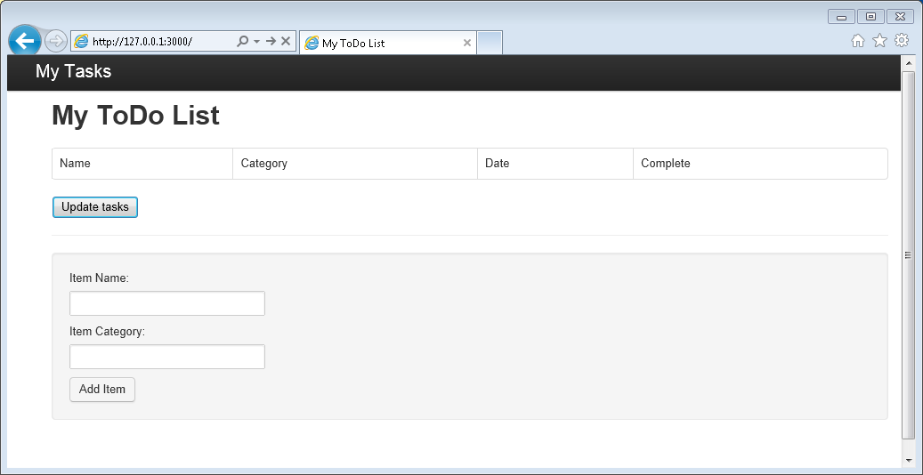

1. Use the provided fields for Item, Item Name and Category to enter information, and then click**Add Item**.
2. The page should update to display the newly created item in the ToDo list.

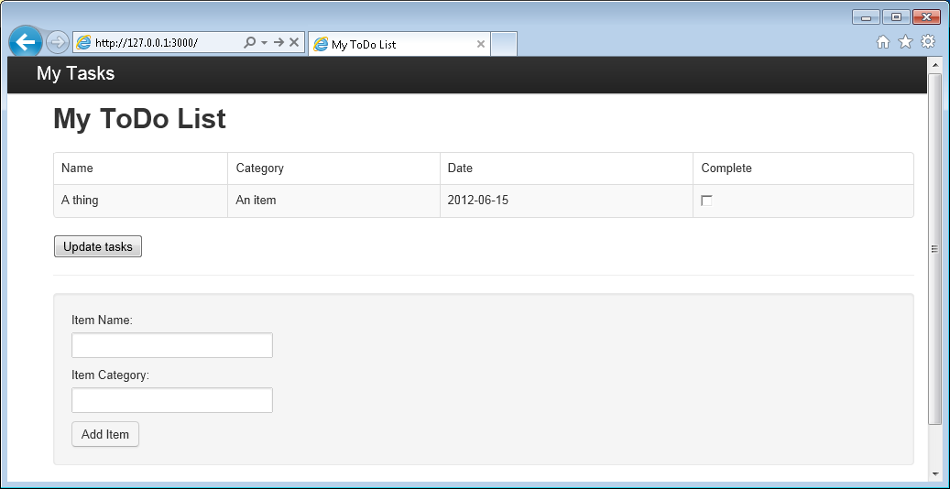

1. To complete a task, simply check the checkbox in the Complete column, and then click **Update tasks**.

## **Step 7: Deploy your application development project to Azure Websites**

1. If you haven't already, enable a git repository for your Azure Website. You can find instructions on how to do this in the [Local Git Deployment to Azure App Service](https://azure.microsoft.com/en-in/documentation/articles/app-service-deploy-local-git/) topic.
2. Add your Azure Website as a git remote.

Copy

git remote add azure https://username@your-azure-website.scm.azurewebsites.net:443/your-azure-website.git

1. Deploy by pushing to the remote.

Copy

git push azure master

1. In a few seconds, git will finish publishing your web application and launch a browser where you can see your handy work running in Azure!

## **Next steps**

Congratulations! You have just built your first Node.js Express Web Application using Azure DocumentDB and published it to Azure Websites.

The source code for the complete reference application can be downloaded from [GitHub](https://github.com/Azure-Samples/documentdb-node-todo-app).

For more information, see the [Node.js Developer Center](https://azure.microsoft.com/develop/nodejs/).